Project Design Phase-II
Data Flow Diagram & User Stories

Date | 31 January 2025
Team ID | LTVIP2026TMIDS38821
Project Name | Exploratory Analysis of Rain Fall Data in India for Agriculture
Maximum Marks | 4 Marks

Data Flow Diagrams:
A Data Flow Diagram (DFD) is a traditional visual representation of the information flows within a system. A neat and clear DFD can depict the right amount of the system requirement graphically. It shows how data enters and leaves the system, what changes the information, and where data is stored.

. It shows:
- How data enters the system
- How it is processed
- Where it is stored
- How it exits the system
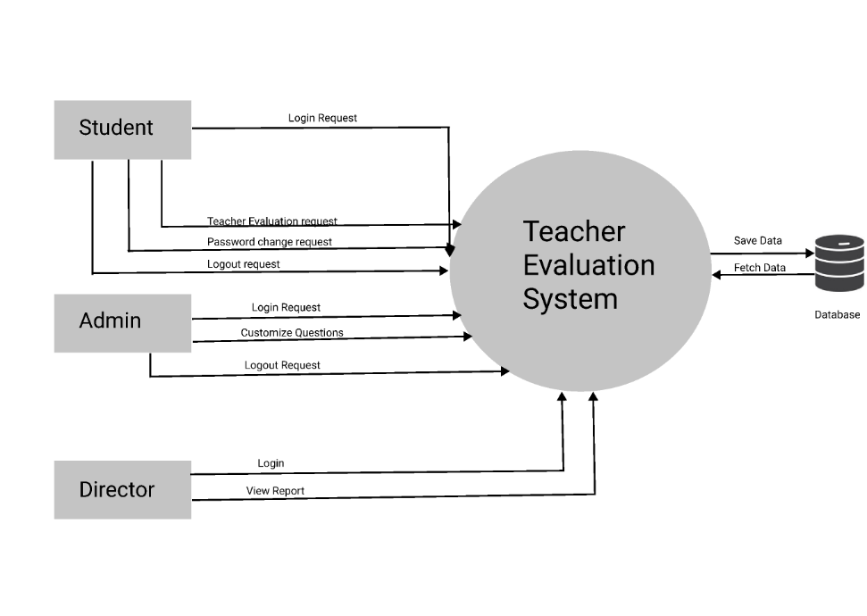
In this project, the DFD represents the flow of rainfall data through the exploratory analysis and prediction system to support agricultural decision-making.
DFD Level 0 (Context Diagram)
Entities:
- Farmer / Agricultural Officer (User)
- Rainfall Prediction System
- Rainfall Dataset Storage
- Trained ML Model Storage
Data Flow:
• User enters rainfall parameters (state, month, season, historical values).
• System receives and validates input data.
• System retrieves historical rainfall dataset for reference (if required).
• System applies trained Machine Learning model for prediction.
• Model accesses trained weights from model storage.
• System generates rainfall prediction output (Expected Rainfall Level / Category).
• Prediction result and trend insights are displayed to the user.

User Stories

User Type | Functional Requirement (Epic) | User Story Number | User Story / Task | Acceptance Criteria | Priority | Release
Farmer (Mobile User) | Rainfall Prediction | USN-1 | As a farmer, I can enter state and seasonal details to get rainfall prediction | System displays predicted rainfall level instantly | High | Sprint-1
Farmer (Web User) | Trend Analysis | USN-2 | As a farmer, I can view historical rainfall trends | System shows graphical trend visualization | High | Sprint-1
Farmer (Web User) | Result Display | USN-3 | As a user, I can clearly see prediction results | Prediction result is displayed in clear format with category (Low/Normal/High) | High | Sprint-1
Agricultural Officer | Risk Assessment | USN-4 | As an officer, I can analyse rainfall patterns for advisory planning | System provides rainfall classification output | High | Sprint-1
Agricultural Officer | Seasonal Comparison | USN-5 | As an officer, I can compare rainfall across seasons | Seasonal comparison chart is generated | Medium | Sprint-1
Admin | Model Management | USN-6 | As an admin, I can retrain the ML model with updated dataset | Model updates and improves evaluation metrics | Medium | Sprint-2
Admin | Dataset Upload | USN-7 | As an admin, I can upload new rainfall dataset | System successfully stores updated dataset | Medium | Sprint-2

